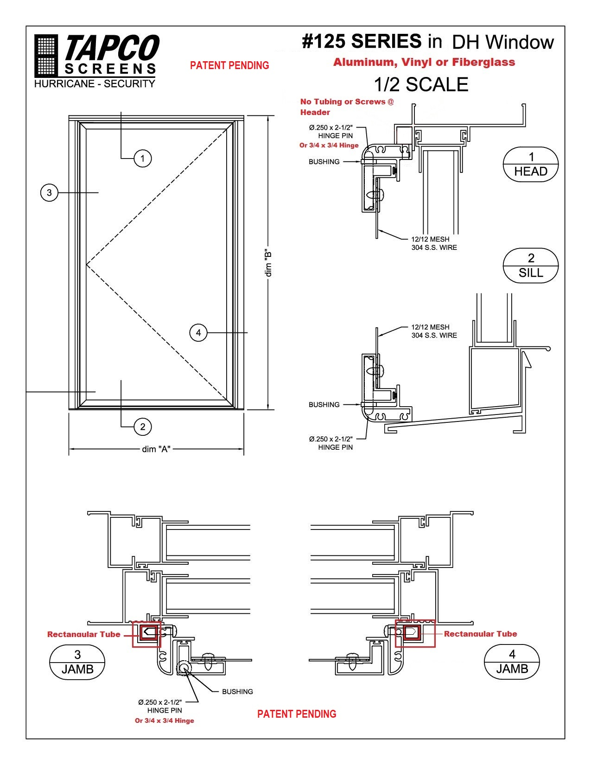
___________________________________________________________________________
1813 McCullough Blvd. 38801 ~ Post Office Box 1427 38802 ~ Tupelo, MS 38801 ~ Ph 1-800-737-8272 ~ Fax 662-844-8511
SECURITY SCREEN SPECIFICATIONS
#125 ECONOMY SERIES
A. Sub-Frame: Extruded aluminum 6063-T5, .062 wall thickness,
1.437" x 1.065 single hollow. Weight per ft .360
B. Main Frame: Extruded aluminum 6063-T5, 1.390" Wide x .966" Height,
.060 wall thickness. Weight per ft .340
C. Corner Gussets: Shall be .250 solid aluminum or welded corners.
D. Spreader Bar: Extruded aluminum 6063-T5, 1.00" x .400" with .060 wall
thickness.
E. Wire Mesh: Stainless steel with natural or painted finish or perforated
with powder coat paint, .028 or .035 12 x 12 mesh.
F. Anchor Bar: Extruded aluminum 6063-T5, 1.00" wide x .060 wall thickness.
Screws not to exceed 4" apart.
G. Hinge: Top or side pivot - 1/4" x 2-3/8" SST pivot rod.
H. Latches: Stainless steel barrel bolt latches or optional single point
release latch.
I. Finish: Mill Finish, Bronze, White

